

**Hakeem Gooden; Berthel Whyte; Raheem Robinson; Johnoy Mendez**

**I-Quad development team**

I-QUAD appointment system User manual

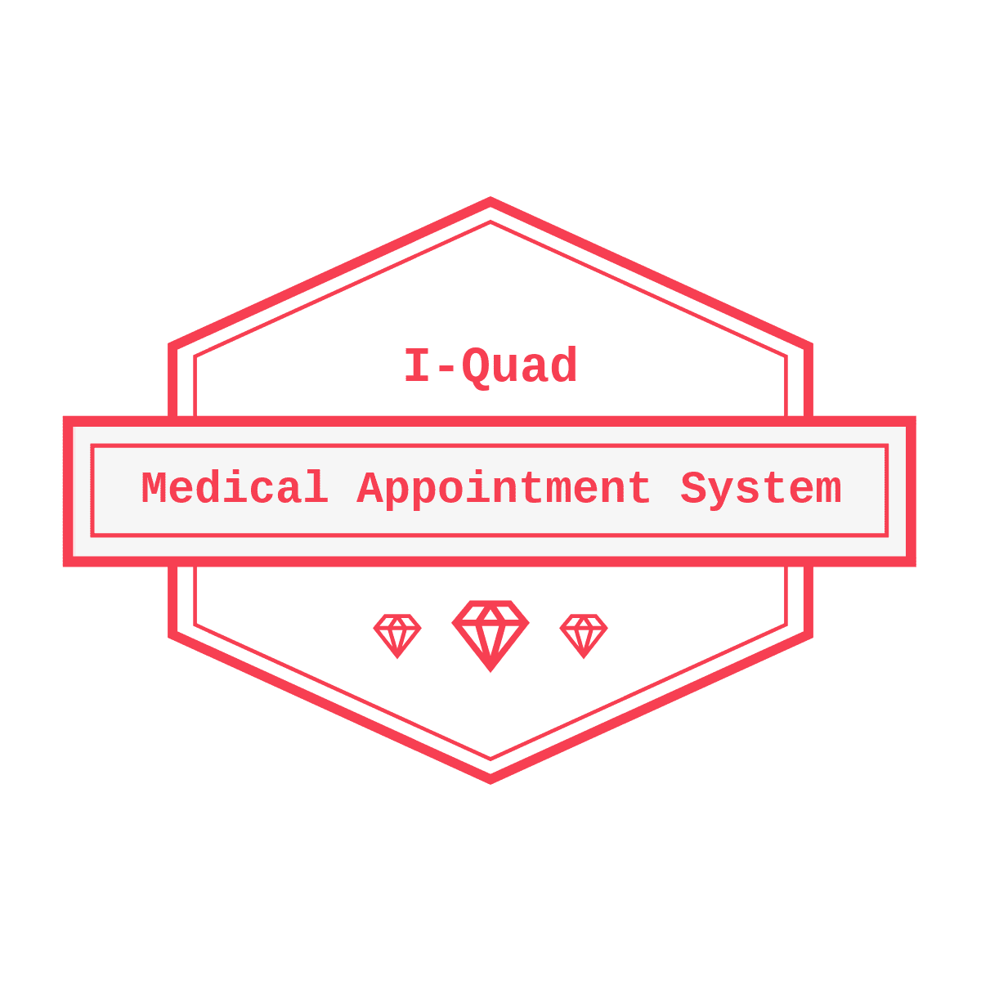

Contents

INTRODUCTION 2

ALL USERS 3

Registering as a User 3

Setting Appointments 4

Viewing Your Appointments 4

Editing Appointments 5

Deleting an appointment 6

ADMINISTRATOR 7

Adding a Role 7

Deleting a role 8

View Roles for a User 8

Adding Roles to Users 9

Removing Roles from a User 9

# INTRODUCTION

The I-Quad Medical appointment system was designed to remove the hassle that comes with setting appointments, giving users more flexible scheduling abilities. This document contains all the necessary guideline in manipulating the system, whether you are a patient, receptionist, or doctor.

# ALL USERS

## Registering as a User

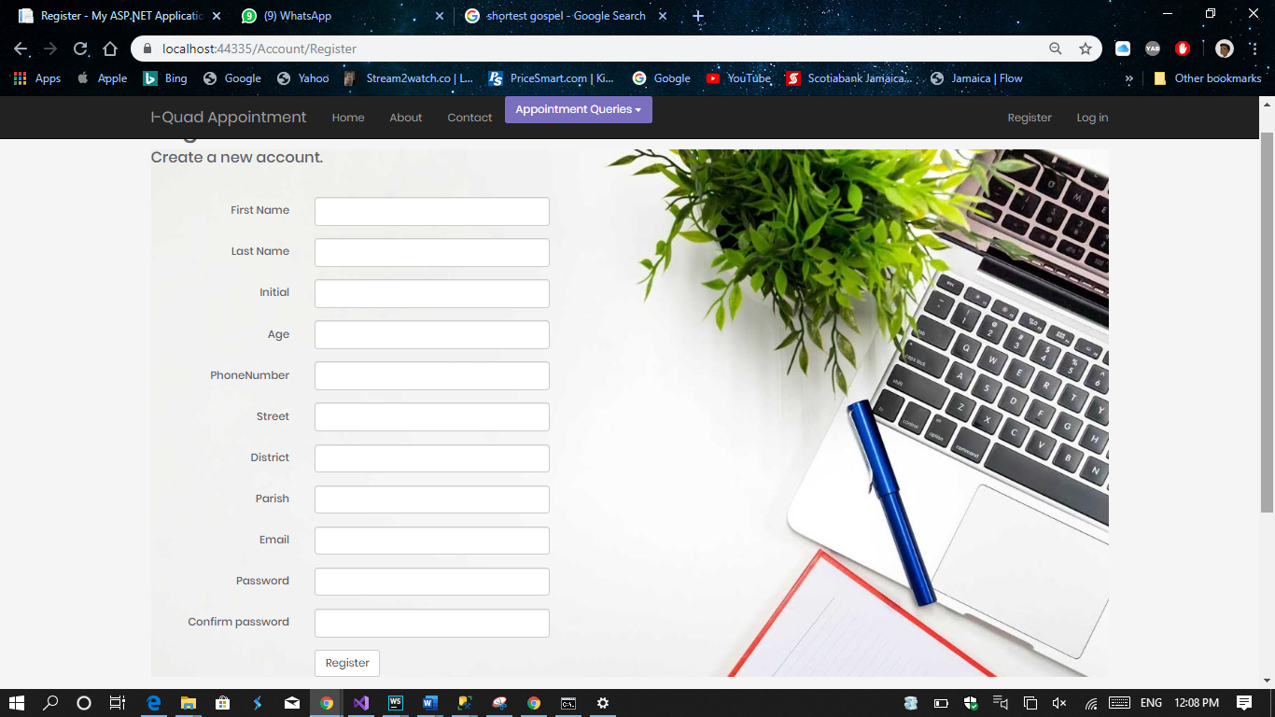

To register, the user must fill out the above form.

Guidelines:

* Password must have at 1 uppercase, 1 lower case, 1 number and 1 symbol.
* Password must be at least 6 characters
* Email address must be valid

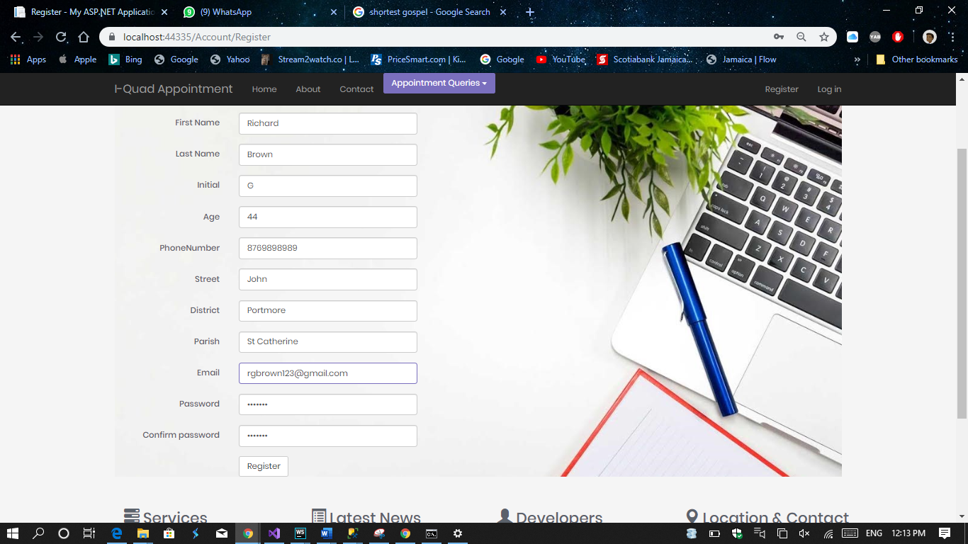

Example of how to properly fill out the registration form

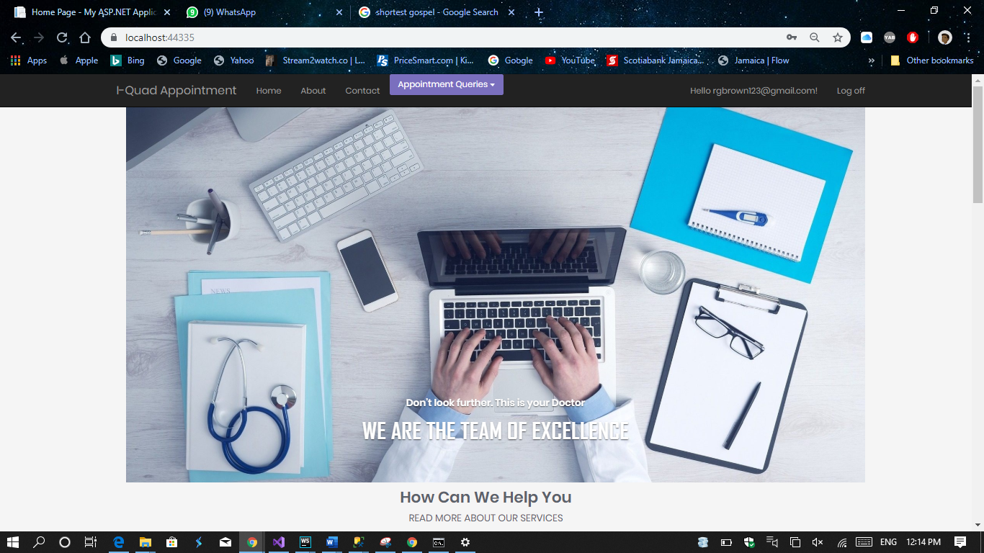

Once registered, the user will be automatically logged in.

## Setting Appointments

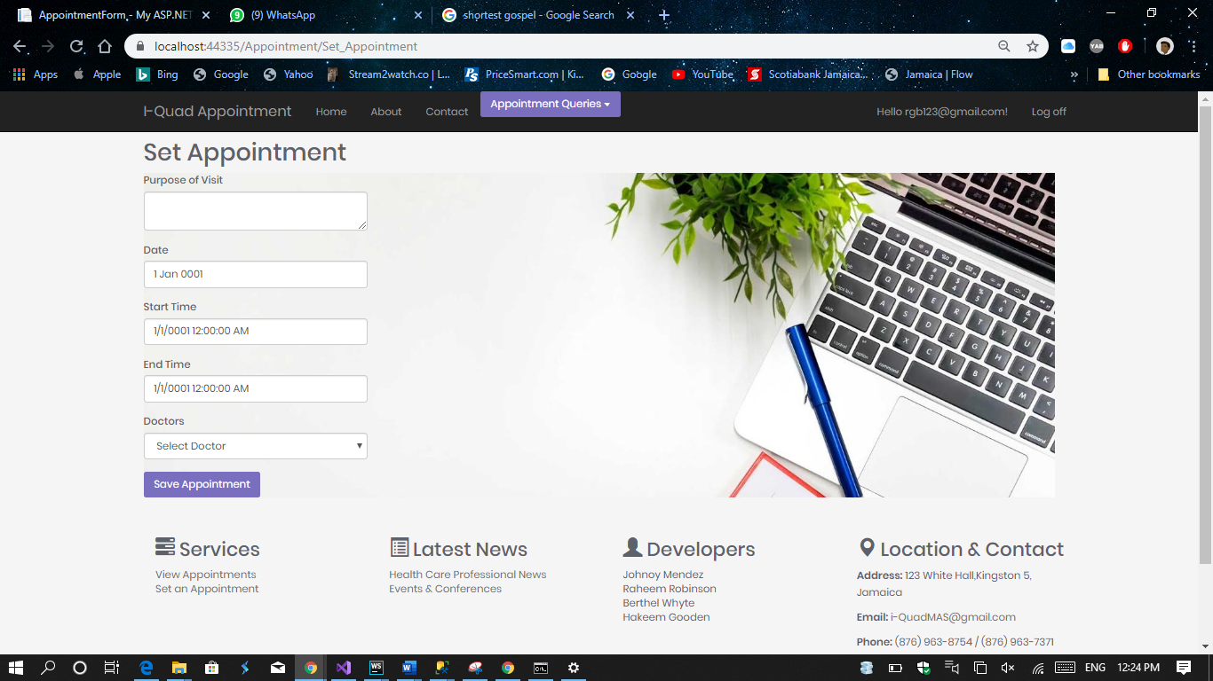

To set an appointment, the user needs to fill out the above form

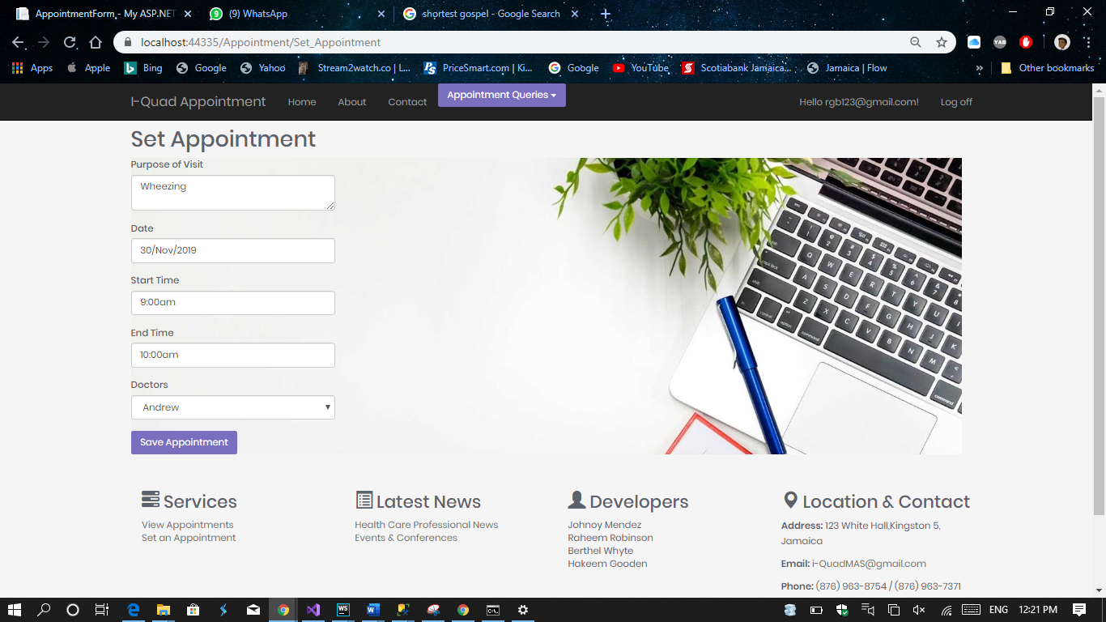

Here’s an example of how to fill out the form

## Viewing Your Appointments

This option allows a user to view all appointments that have been set by them. Here are the guidelines.

1. Select the “Appointment Queries” option on the navigation bar
2. Select View Appointments.

Example: Viewing all appointments set by User Fae Elliot

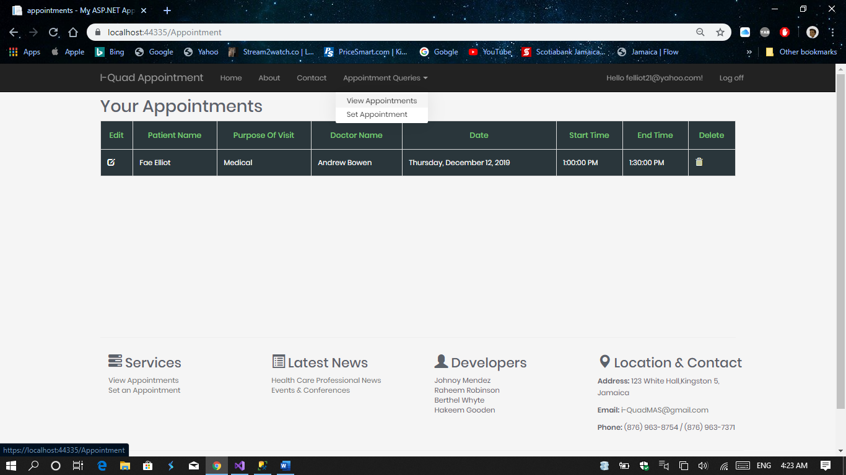

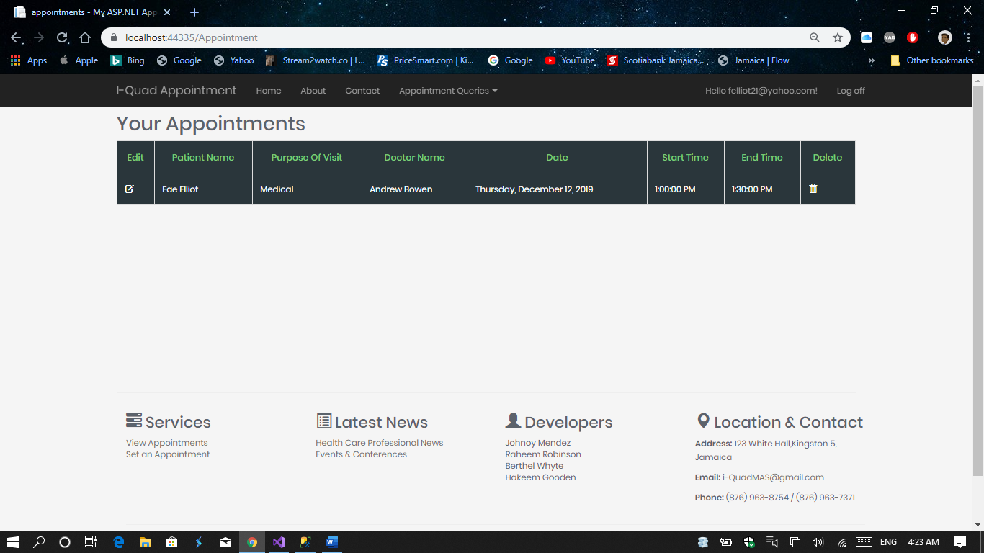

## Editing Appointments

This option allows the user the edit details about and appointment they have set. Here are the guidelines.

1. Select the icon under the Edit pane
2. Edit the information you want to change
3. Select save.

Example: Changing the appointment date for user Fae Elliot



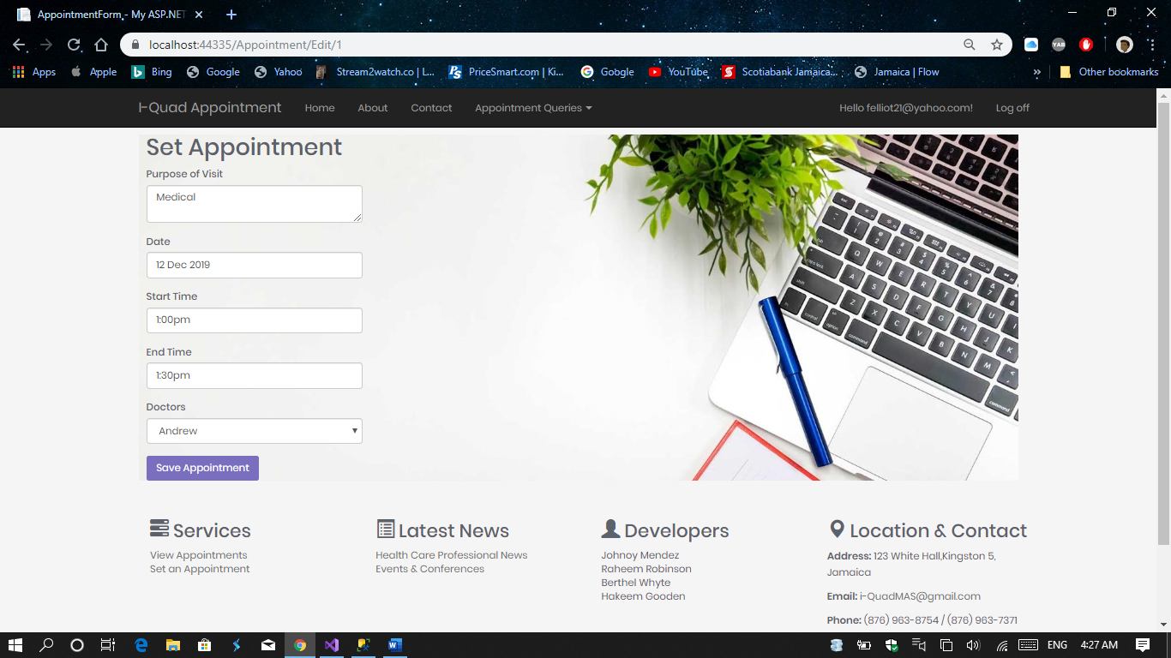

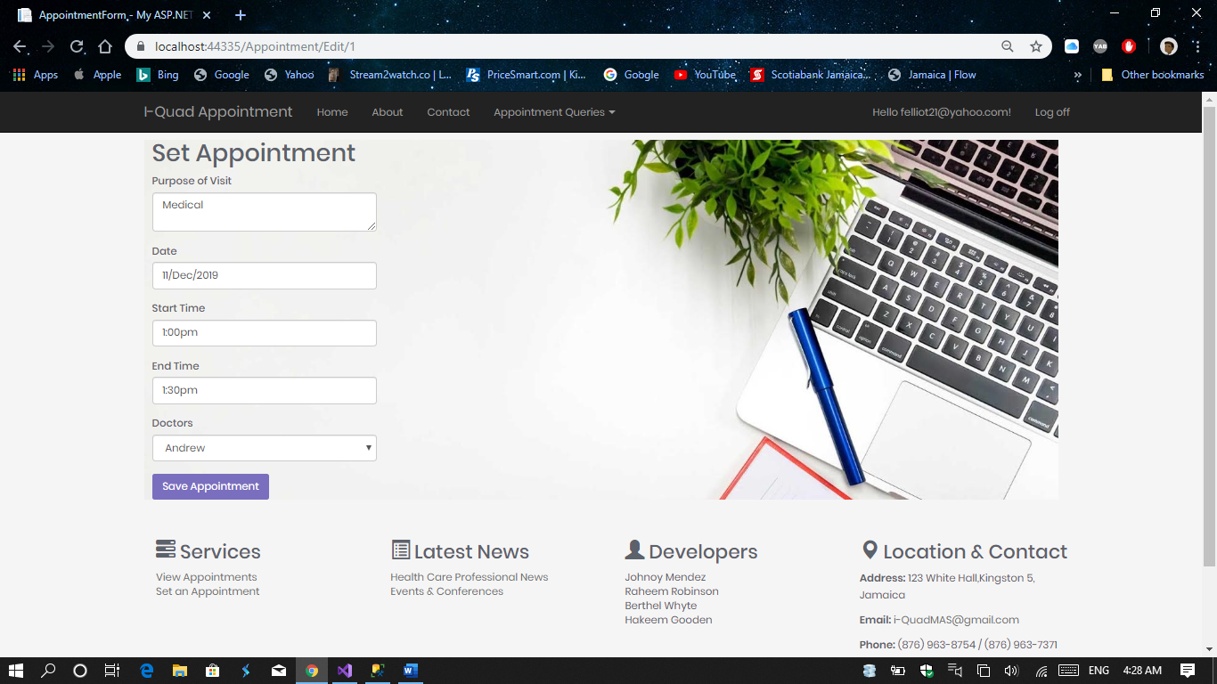

## Deleting an appointment

This option allows a user to delete an appointment. Here are the guidelines.

1. Navigate the view appointments page and previously stated.
2. Select the icon under the delete pane

Example: Deleting the appointment set by User Fae Elliot



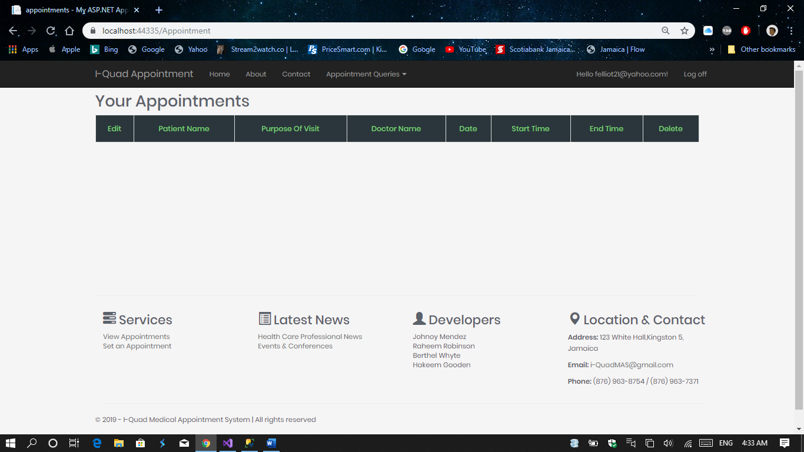

The appointment has been deleted.

# ADMINISTRATOR

Default admin email: [Admin@gmail.com](mailto:Admin@gmail.com)

Password: !@#456Am

Admin Panel

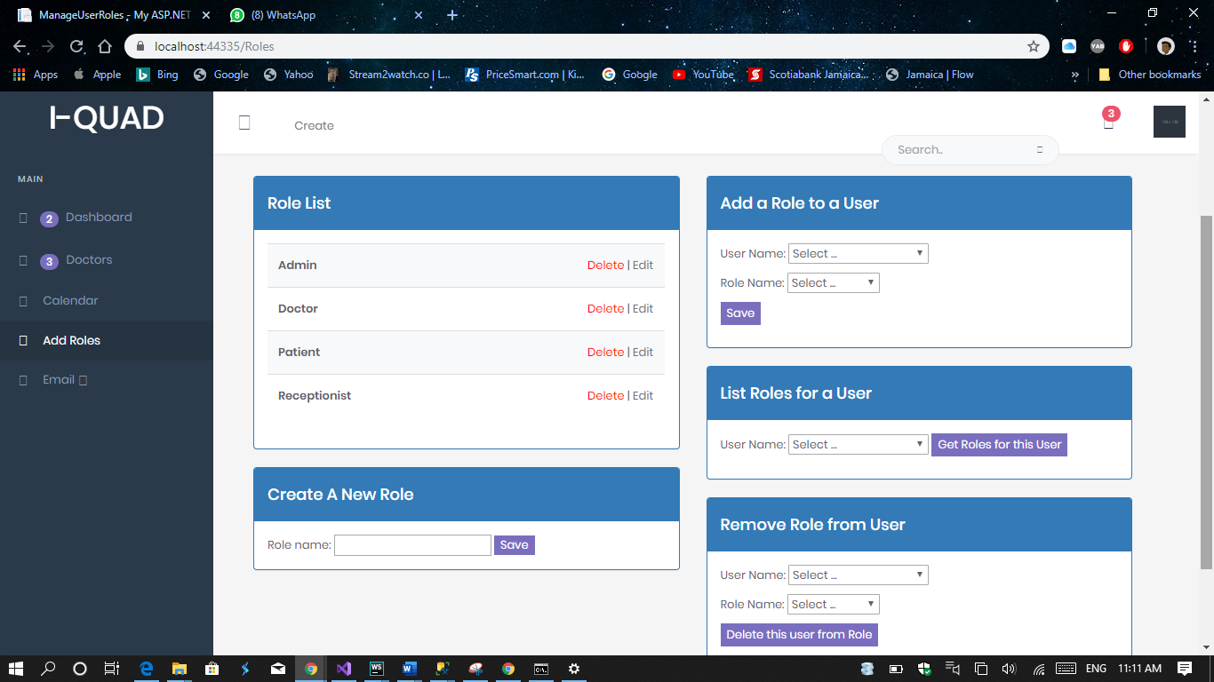

From this screen, an administrator can create/delete roles from the system, add a role to a user, list all user roles, and remove roles from a user

## Adding a Role

1. Under the “Create Role Section”, type the name of the role.
2. Press Save

Example Role: Nurse

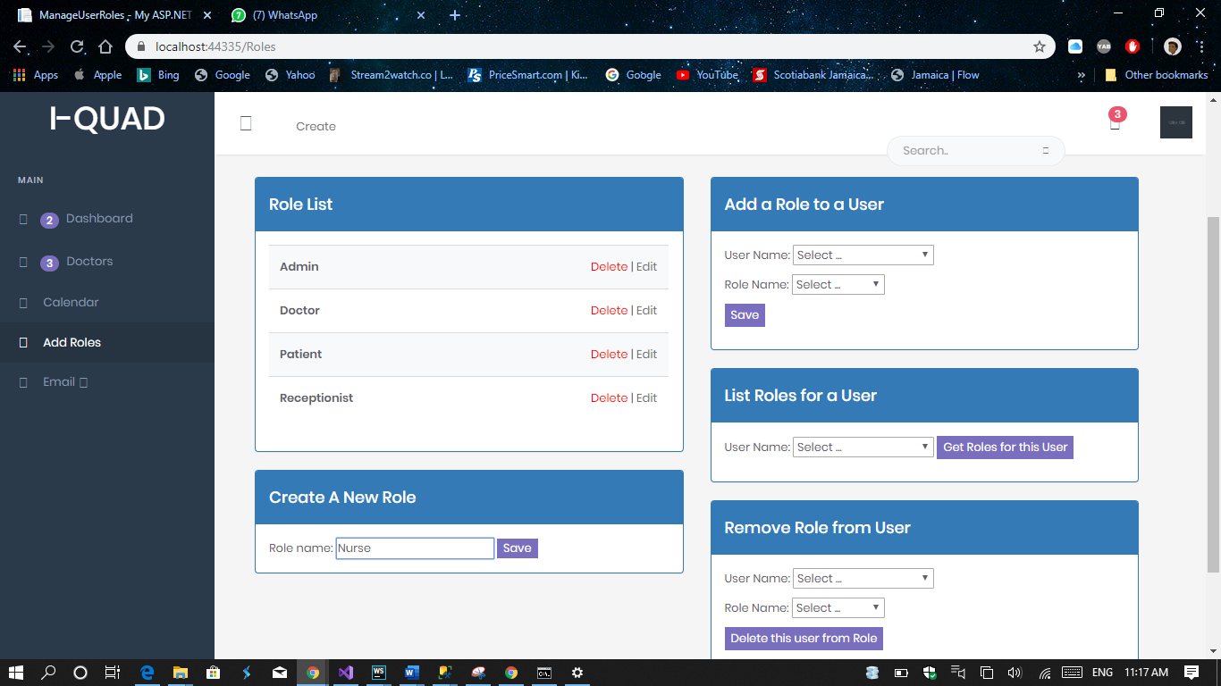

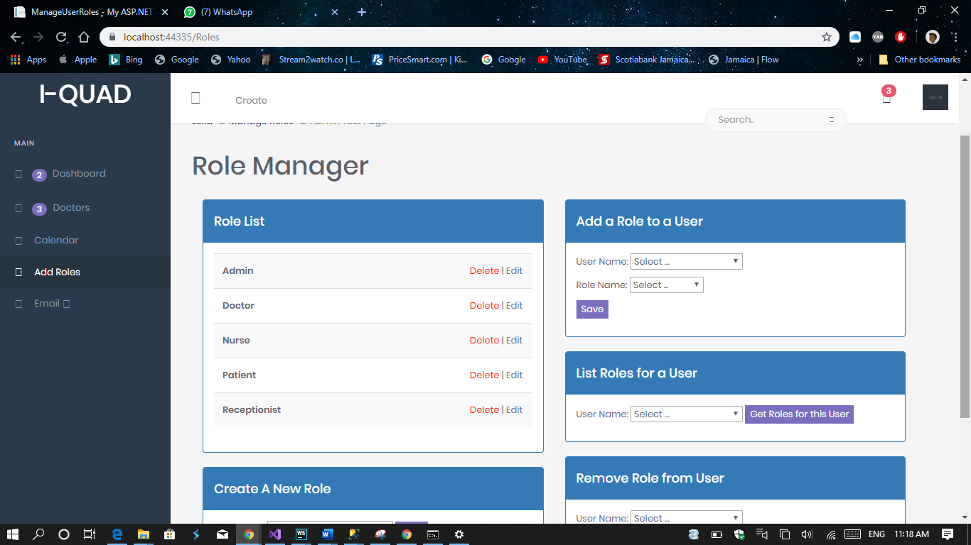

Nurse role added to list of roles

## Deleting a role

1. Under the “Role List” section, select delete.
2. When asked if you want to delete, select “Yes”.

Example: Deleting Nurse Role

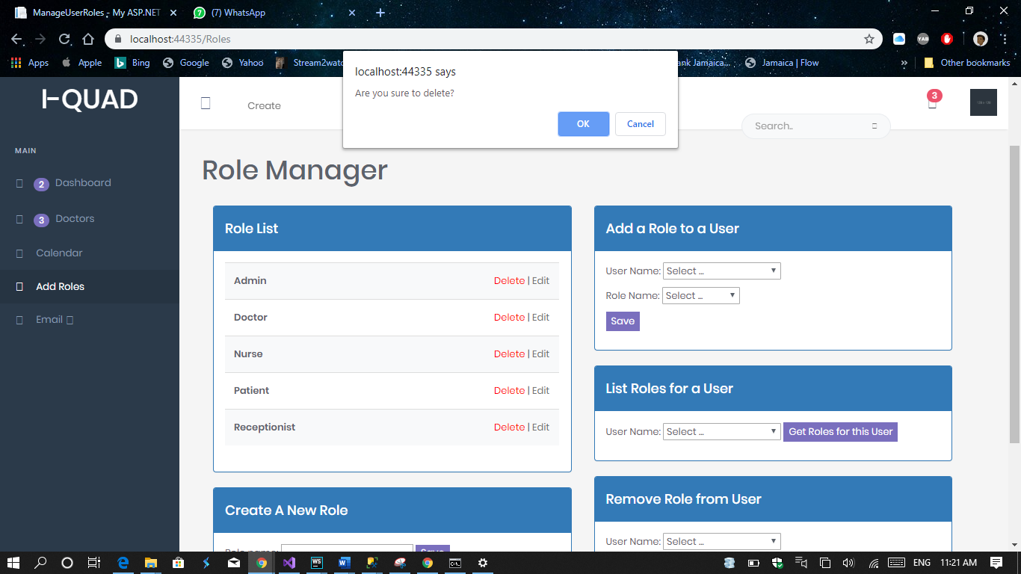

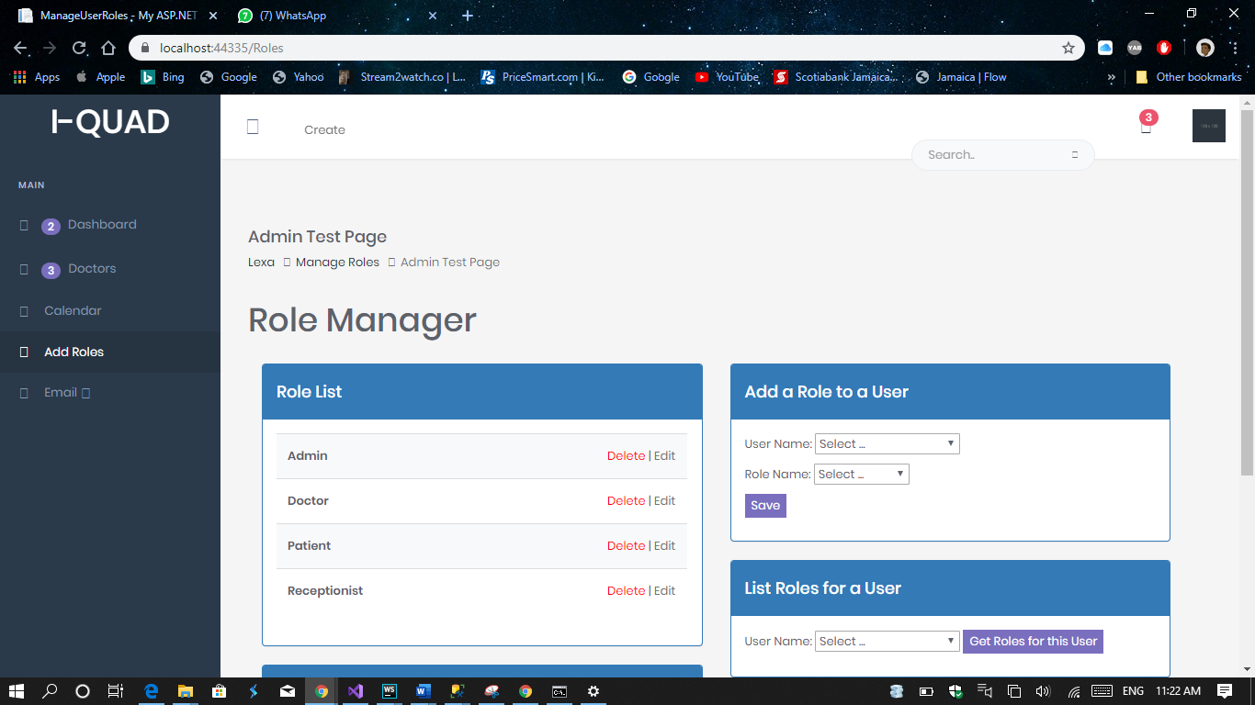

Nurse Role Deleted

## View Roles for a User

1. Under “List Roles for a User”
2. Select the user
3. Select get roles for this user

Example: Viewing Roles of an existing user

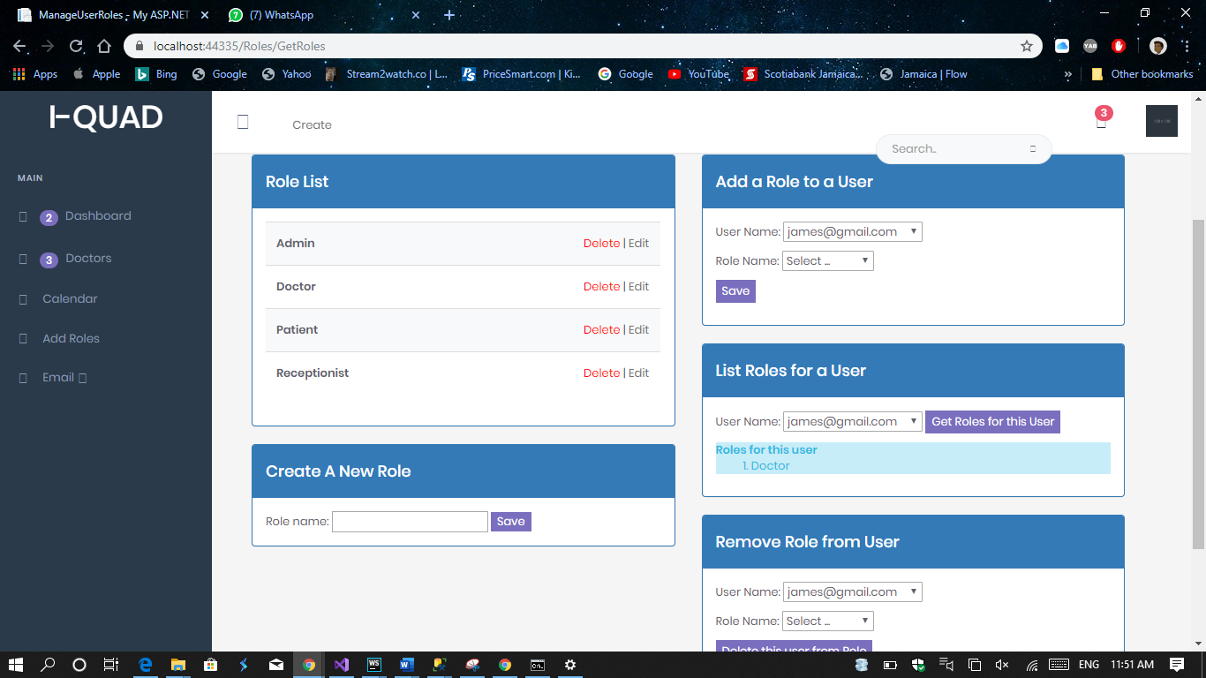



Roles for this user listed

## Adding Roles to Users

1. Under the “Add Roles to User” section, select the user.
2. Select the role to add to the user.
3. Press Save.

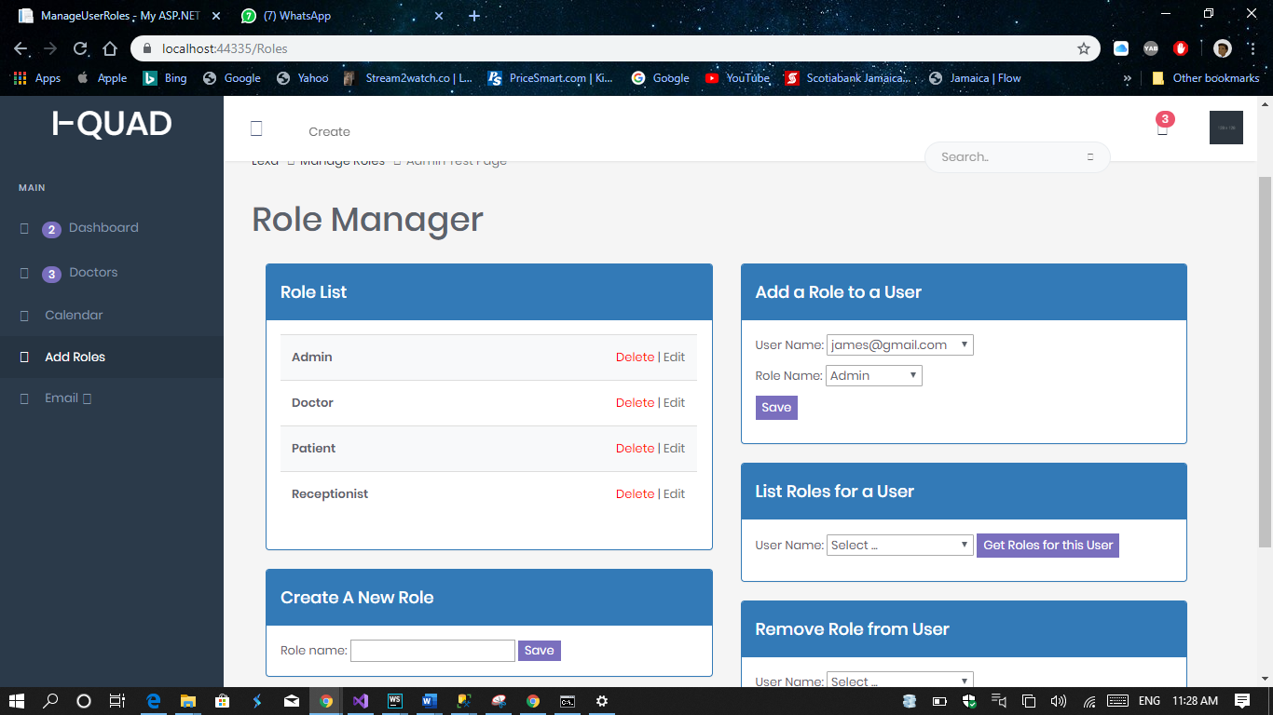

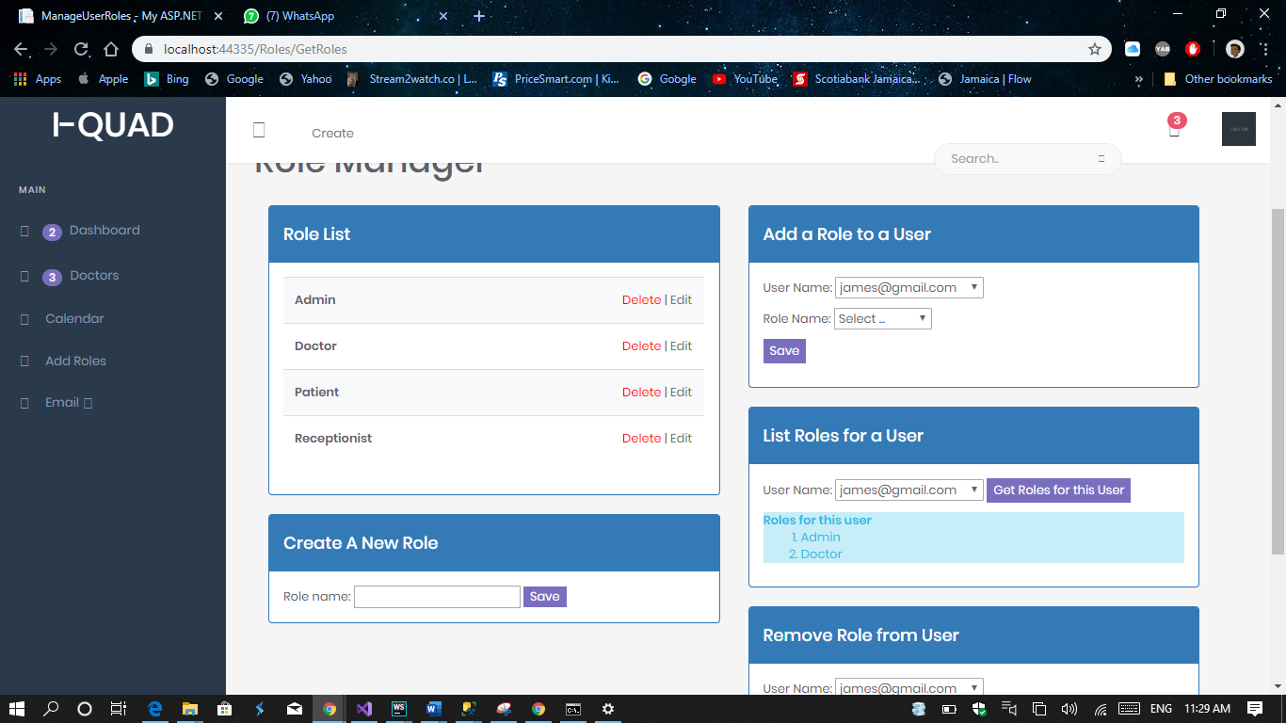

Admin role added to user

## Removing Roles from a User

1. Under the “Remove Role from User” section, select the user.
2. Select the role to be deleted.
3. Select Delete this user from Role

Example: deleting Admin role from default user

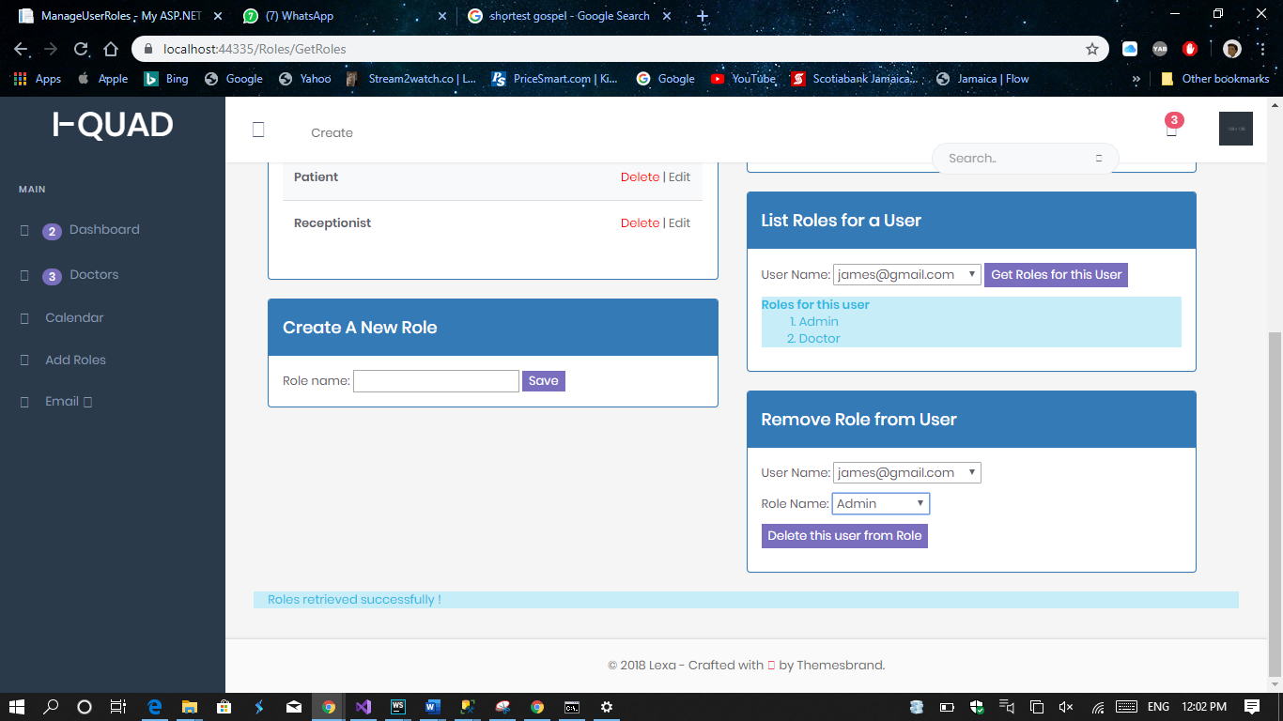

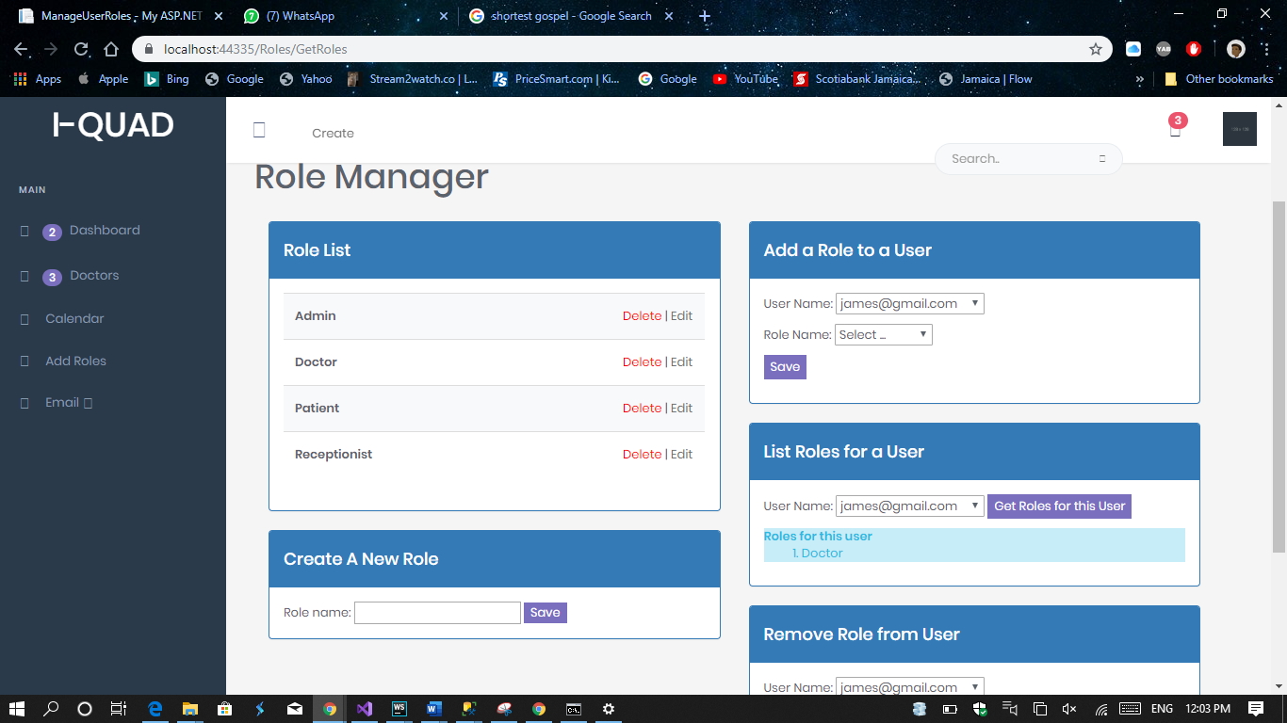

Admin Role Deleted